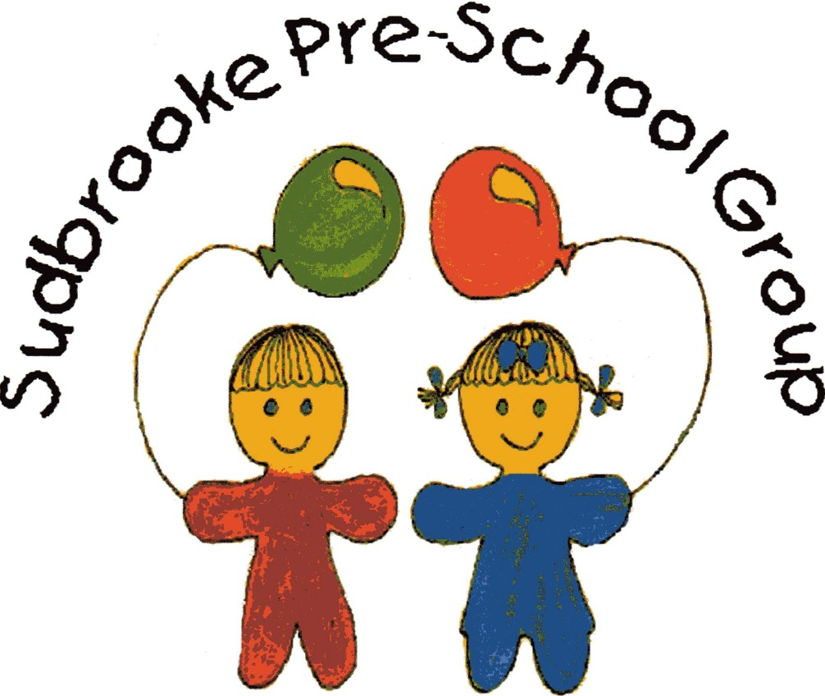

Information Pack

Sudbrooke Pre-School Group

A member of the Pre-school Learning Alliance and OFSTED inspected

Sudbrooke Pre-School Group

We would like to take this opportunity to welcome your family to Sudbrooke Pre-School Group.

Sudbrooke Pre-school Group was first established in 1987 and operates from Sudbrooke Village Hall, serving the children and families of Sudbrooke and the surrounding villages. Our sessions are as follows;

**Monday, Tuesday, Wednesday and Thursday: 9.00am to 12.00pm and 12.00pm to 3pm**

**There is also the option for the children to stay for the lunch hour which is 12.00pm to 1pm.**

Our pre-school terms coincide with dates as issued by the LEA which also coincide with Ellison Boulters School. We occasionally close for staff training days or when the village hall is used as a polling station. Term dates are displayed on our notice board, along with other information and updates and is located in the entrance hall during sessions. In the event of unforeseen closure, families will be contacted by telephone and a post will be uploaded onto our Facebook page.

The pre-school is registered to cater for a maximum of 24 children in any one session. Children can join pre-school at 2 years old and we do not require them to be toilet trained. We provide funded early years education for two-year-olds and three- and four-year-olds and support children with English as an additional language and children with Special Educational Needs or disabilities.

We encourage new parents/carers to visit our pre-school with their child in order to gain an insight into our routines, activities and objectives. It offers an opportunity for the child to familiarise themselves with the environment, staff and other children. It also provides the parents with time to raise questions, discuss concerns or express any individual needs for their child. We welcome parents into our group at any time, but in order to ensure that the manager is available to meet new parents/carers, we would recommend making an appointment. For further information or to arrange a visit, please contact Sudbrooke Village Hall on 01522 754047 during session times and ask to speak to Laura, the manager.

The pre-school is a member of the Pre-school Learning Alliance and Ofsted registered. Our most recent Ofsted inspection was in November 2022, for which we were awarded ‘Good’ across all areas of inspection. Our Ofsted inspection is available to view at the pre-school or from the Ofsted website.

**Staff Members**.

### Staff

###### Manager Mrs Laura Hutchinson

###### Deputy Manager Mrs Kelly Tyrrell

## Assistants Mrs Rachel Gray

## 

## Bank Staff Mrs Vicki Timings-Thompson Mrs Olwen Edwards

**Special Educational Needs** Mrs Laura Hutchinson

**Co-ordinator (SENco)**

**Safeguarding Officer** Mrs Kelly Tyrrell

We adhere to current Ofsted staffing requirements which state that the minimum staffing ratios are:

Children aged 2 years 1 adult to every 5 children

Children aged 3 to 7 years 1 adult to every 8 children.

It is our intention whenever possible to exceed these ratios in order to provide a high level of adult assistance, support and guidance for the children in our care.

**Staff Training and Qualifications**

The manager holds a Level 6 Ba Hons degree in Professional Studies in Early Childhood. The Deputy manager is qualified to Level 2 and currently undertaking her Level 3 in Childcare and Education. This allows the setting to adhere to the Early Years Foundation stage welfare requirement for qualified staff on duty at any one time. All staff hold a Level 1 safeguarding qualifications. 2 members of staff hold a Paediatric First Aid Certificate, and one member of staff is first aid trained.

At least two members of staff on duty will hold a full Paediatric First Aid Certificate. Further relevant workshops and training attended by staff are listed on the parents notice board located in the hall.

Everyone working at Sudbrooke Pre-School has been DBS checked before they commenced employment. Staff are recruited within an Equal Opportunities framework.

**Management**

Our pre-school is run by an elected management committee, consisting of parents/carers or members of the community, who volunteer their time and services to the group. The management committee is made up of the Chairperson, Treasurer and Secretary, as well as general committee members, elected at the Annual General Meeting (AGM). The committee meet informally every 6-8 weeks, to discuss topics such as staffing and recruitment, finances and fundraising initiatives. The AGM is held in June to which all parents/carers are invited.

**The support, involvement and contributions parents/carers make is essential to the smooth running and existence of our pre-school group.** Any parent/carer interested in joining our management committee should speak to the chairperson.

## Management Committee

## Chairperson Miss Louise Baker

## Treasurer Mrs Vicki Timings- Thompson

**Secretary** Mrs Olwen Edwards

**Registration Secretary** Mrs Laura Hutchinson

**General Committee members** Mrs Lawra Start

Mrs Bev Bell

Mrs Christina Fry

**Early Years Foundation Stage and Areas of Learning.#**

**The EYFS**

**The EYFS Framework**

The EYFS is a framework for children’s development from birth to the end of their first year in school (reception). The framework sets the standards that all early year’s practitioners must meet to ensure that children learn and develop well and are kept healthy and safe.

There are seven areas of learning and development that shape educational programmes in early years settings. All are important and interconnected. Three areas are identified as being particularly crucial in igniting children’s curiosity and enthusiasm for learning and to build their capacity to learn, form relationships and thrive. These three areas, the **prime areas**, are:

* personal, social and emotional development;
* communication and language; and
* physical development.

Providers must also support children in four **specific areas**. These are:

* literacy;
* mathematics;
* understanding the world; and
* expressive arts and design.

At Sudbrooke Pre-School Group we aim for all children attending to experience a stimulating, enjoyable and rewarding time with us. We aim to meet the requirements of the EYFS through an educational programme of experiences and activities, which considers the individual needs, interests and stage of development of each child in our care. Practitioners working with the youngest children will focus on the three prime areas, which are the basis for successful learning in the other four specific areas. The three prime areas reflect the key skills and capacities all children need to develop and learn effectively. It is expected the balance will shift towards a more equal focus on all areas of learning as the children grow in confidence and ability within the three prime areas.

**The Prime Areas**

**Personal Social and Emotional Development** involves helping children to develop a positive sense of themselves, and others; to form positive relationships and develop respect for others; to develop social skills and learn how to manage their feelings; to understand appropriate behaviour in groups; and to have confidence in their own abilities.

**Communication and Language** development involves giving children opportunities to experience a rich language environment; to develop their confidence and skills in expressing themselves; and to speak and listen in a range of situations.

**Physical Development** involves providing for young children to be active and interactive; and to develop their co-ordination, control and movement. Children must also be helped to understand the importance of physical activity, and to make healthy choices in relation to food.

**The Specific Areas**

**Literacy** development involves encouraging children to link sounds and letters and to begin to read and write. Children are given access to a wide range of reading materials (books, poems and other written materials) to ignite their interests.

**Mathematics** involves providing children with opportunities to develop and improve their skills in counting, understanding and using numbers.

**Understanding the world** involves guiding children in their understanding of past and present, people, culture and communities and the natural world

**Expressive arts and design** involves enabling children to explore and play with a wide range of materials, as well as providing oppourtunities and encouragement for sharing their thoughts, ideas and feelings through a variety of activities in art, music, movement, dance and role-play.

**Our Sessions**

Our sessions are organized so that the children are provided with a balance between more structured activities that may require a greater degree of adult support and free play which is more child directed. Such activities allow children time to explore, play and learn independently, with adult support when necessary. The children have opportunities to play and learn on a one-to-one basis, in small groups with their key person and to participate in whole group activities, both indoors and outdoors. There is a balance between quiet times, e.g. listening to a story and the more energetic play such as ride on toys or the use of the play park. All sessions are tailored to suit individual needs, abilities and interests and at this stage the emphasis is still very much on learning through play.

**Transition to Primary School**

The majority of children move on to primary school at Ellison Boulter’s C. of E. Primary Academy. We maintain links with the school and the children are invited into the school to watch friends and siblings perform in the Reception/Key Stage 1 Nativity Play. The reception class teacher also spends a couple of afternoons with our children here at pre-school. The children’s Learning Journeys recorded here, are celebrated and shared with the teaching staff at Ellison Boulter’s.

**Key Person and Progress Records**

Each child is assigned a key person: this means that each child w**ill** have a designated key person whose role is to help ensure that every child’s care is tailored to meet their individual needs, to help the child become familiar with the setting, offer a settled relationship with the child, and build a relationship with their parents. It also provides parents/carers with an initial point of contact; however, all members of staff are responsible for the involvement and wellbeing of every child attending on all sessions.

# During a child’s time at pre-school the key person will observe, assess and record their progress. This enables us to understand the needs of individual children and provides us with the information we require in order to extend their learning and development. It is our intention for all children to be given the opportunity to achieve. Your child’s progress and development is recorded in their individual Tapestry online Learning journey, which is freely available for parents/carers to view and contribute to.

**Progress Check at Age Two**

The Progress Check at age two requires that parents/carers are supplied with a short, written summary of their child’s development in the three prime learning and development areas of the EYFS. The purpose of the progress check is to describe your child’s current level of development, but more critically, to identify any aspects that may indicate developmental concerns and how these are being addressed.

This statutory requirement states that the progress check must take place between the ages of 24– 36 months. The timing of the check will be dependent on patterns of attendance. Practitioners will need to build up a clear picture of your child before being able to write the report.  The progress check will be carried out by a practitioner who knows your child well and works directly with them. This will usually be your child’s key person.The progress check will involve a range of viewpoints from your child, parents, other practitioners within the setting and other professionals who may work with your child.

**Policies and Procedures**

Sudbrooke Pre-school Group has a full range of policies and procedures and a **risk assessment,** the intention of which is to ensure that we have addressed all areas relating to the welfare, safety and education of the children in our care. Our policies and procedures also attend to the needs of the adults in the group, in particular developing and maintaining a positive working partnership between parents/carers and pre-school staff including the management committee.

Below is a brief outline of some of our policies and procedures, full copies are available at any time during pre-school sessions. Parents/carers may also request to borrow a copy to read in depth.

In particular we would draw your attention to the;

* **Confidentiality Policy:**  We are conscious of the fact that personal information regarding a child, their family and staff is given to us in the form of records, conversations and in meetings. We take every step to ensure that an individual’s right to privacy and confidentiality is upheld.
* **Equal Opportunities Policy:** We are committed to treating all children and adults with equal care and concern. We recognize that it is our differences that make us individual and unique; these differences are valued and celebrated.
* **Safeguarding Children Policy:** The welfare, safety and protection of children are of paramount concern to us and we are committed to providing an environment in which children are safe from abuse. Any suspicion of abuse will be dealt with sensitively and appropriately in order to ensure the safety of the child.
* **Additional Needs:** We recognize that all children have different needs and that some children have a special educational need or a special need relating to a medical condition or disability. Our aim is to work in partnership with the parents/carers and child to provide care, play and learning opportunities best suited to their needs, so that they can progress and achieve. We are committed to following the Government’s *SEN Code of Practice*. If any concern with a child’s development is considered, the supervisor will discuss these concerns with the child’s family or carer. Early Years and Childcare support (EYCC) will be contacted with any concerns but only with prior permission from the parents/carers, who will of course be given the opportunity to discuss any concerns directly with EYCC.
* **Behaviour Management Policy:** Children should be free to play and learn without fear of being hurt, hindered or threatened by peers or adults and achieve their best in an environment that is ordered and in which they understand what is expected of them. It is our intention for children to feel safe and happy; this is in part achieved through a consistent approach to managing behaviour, mutual respect, praise and encouragement.
  + **Complaints Procedure:** We welcome suggestions and comments from parents/carers and believe that most complaints are made constructively. All complaints will be taken seriously, dealt with promptly and fairly, in a way that respects confidentiality.

**General Information**

**Partnership with Parents**

We welcome any information from home about your child’s interests, achievements and challenges and will regularly share information with you regarding your child’s progress at pre-school, through informal chats and sharing observations on your child’s Tapestry Learning Journey.

We have an ‘Open Door Policy’ so please feel free to pop in to speak to us at any time.

**Mid-morning Snack bar**

Refreshments are provided during the morning session. The children are offered a selection of fruit, toast and a biscuit. If we have any Birthdays to celebrate, it is during this part of the morning that we sing ‘Happy Birthday’ and share cake. We ask parents to make it known to the pre-school of any food allergies, preferences, likes/dislikes that their child may have. Parents must record any known food allergies on their child’s Registration Form.

**Water bottles**

In order that your child can access a drink throughout the morning/afternoon as required, it is requested that a named bottle of water/sugar free juice is provided from home. We can re-fill these during your child’s time at preschool.

**Packed Lunches**

In line with our Healthy Eating Policy, we would encourage those children that stay for a packed to be provided with healthy choices. Any uneaten food will be sent home in their lunch box in order that you can be informed on what they have eaten. We encourage the use of cool packs, particularly in the warmer weather.

For a charge of £6.00, we welcome any children to stay for an additional lunchtime session. These extra sessions will be invoiced at the end of each month.

**Clothing/Footwear**

# We ask parents/carers to consider the suitability of certain clothing and footwear for pre-school. For example, clothing that is easy for your child to manage when going to the toilet (in order to encourage independence) and ordinary shoes, plimsolls or trainers rather than open toe sandals, which do not provide adequate protection. We make use of the outdoor area, including the play equipment, the field, our garden area and the patio, which allows for free access to the outdoors, so please could you provide sensible footwear/clothing according to the weather. Please label all clothing/personal belongings with your child’s name.

‘Dress for mess!’ Our children have lots of sensory play activities, so please dress your child for ‘mess’ so they can enjoy these activities to the fullest. We do provide aprons but sometimes some children aren’t too keen on wearing them so dressing for mess is the safest option to save their best clothes getting stained.

If your child is toilet training, we ask that you provide at least 2 pairs of pants/knickers, trousers and socks etc. This then ensure we have plenty of spare clothes should we need to change your child during the session, thank you.

# Safety & Welfare of Children in Our Group

**Information we hold about you and your child:**

We have procedures in place for the recordings and sharing of information about you and your child that is compliant with the principals of the General Data Protection Regulations (2018) as follows:

The data we collect is

1. Processed fairly, lawfully and in a transparent manner in relation to the data subject (you and your family)
2. Collected for specified, explicit and legitimate purposes and not further processed for other purposes incompatible with those purposes.
3. Adequate, relevant and limited to what is necessary in relation to the purposes for which the data is processed.
4. Accurate and where necessary, kept up to date.
5. Kept in a form that permits identification of data subjects (you and your family) for no longer than is necessary for the purposes for which the personal data is processed.
6. Processed in a way that ensures appropriate security of the personal data including protection against unauthorised or unlawful processing and against accidental loss, destruction or damage, using appropriate technical or organisational measures.,

**Child Collection**

The safety and welfare of the children in our care is a primary concern to us. It is essential that parents/carers inform us on their child’s Registration Formof those adults that have authority to collect their child from pre-school. If you are unable to collect your child for any reason at the end of a session, the manager/deputy manager must be notified in person or by letter granting permission for a friend or relative to collect the child. Should a member of staff have doubts as to the authenticity of the person collecting a child, pre-school reserve the right to refuse to release the child into their care.

Late collection will incur a charge of £3 for every 15 minutes that you are late. Please be aware that we are not insured to have children on the premises after 3pm so please make sure you are prompt with collection, thank you.

**Accidents**

Should a child hurt themselves whilst at pre-school, a record of the accident or incident will be recorded in our *Accident Record Book* and we will ask parents/carers to sign to show that they have been informed. **At least one member of staff with current Paediatric First Aid training will be on the premises at any one time.**

# Medication and Illness

# If a child requires prescribed medication whilst at pre-school, we will need written consent from the parents/carers in order to allow staff to administer the medication. Staff should also be informed if your child has been administered any medication prior to the session, in order to inform doctors/paramedics in the event of an accident.

If for any reason your child is unable to attend a session, we would appreciate notification either directly or through another parent/carer. It is important that we are informed at an early stage of any infectious illness/diseases. If your child has had diarrhoea or vomiting within **48 hours** prior to a session, we request that they remain at home in the interests of the other children & staff within the group.

# Insurance

Sudbrooke Pre-school Group is insured through the *Pre-school Learning Alliance* with *Sun Alliance.* A copy of our insurance policy is kept on the pre-school notice board in the entrance hall. We regret that our pre-school Group cannot take responsibility for loss or damage to clothing, spectacles, toys or any other items brought into the setting. We are not covered on our insurance for this.

# Fees & Early Years Education Entitlement (EYEE)

Our Registration Fee is £10.00 due at the time of registration and non-returnable. Fees are currently £18.00 per session (if your child is not eligible for EYEE).

The manager or deputy manager will issue individual bills to parents/carers via email. We accept fee payments via BACs. Detail of which are on the monthly bill.

We regret that refunds are only made in exceptional circumstances. Should your child be unable to attend pre-school for whatever reason, including sickness and holidays, the session must still be paid for. We are committed to ensuring that children and their families are not discriminated against on financial grounds. We will therefore offer a flexible payment system should it be required, information regarding this can be obtained from the Manager.

**The Early Years Education Entitlement now offers 15 hours of free early years provision for 2-year-olds starting the term after their second birthday as well as 15 or 30 hours of free early years provision for 3-year-old children from the funding period following their third birthday.** Attendance over these hours for funded children will incur an additional charge. Full details regarding funding can be obtained from the manager and we will require you to complete some forms supplied by us in order to receive the funding. We are also registered to accept Childcare vouchers and we are registered on the tax-free childcare scheme, details of which are available from the Manager.

The pre-school will endeavour to be flexible regarding attendance patterns so as to accommodate the needs of individual children and families. However, it is preferred that children attend at least two sessions per week in order to settle and feel involved in the pre-school’s activities. A waiting list will be kept of those children registering who have not yet reached the age of 2 years. Allocation of places will be in order of date of birth. Priority will be given to children of eligible age for Early Years Education Entitlement. Wherever possible, a half term’s notice of your intention to withdraw your child from the group should be given.

If you require an extra session for your child, we would be grateful for at least 48hrs notice of this so we can organise staffing and ratios. We can also only offer this facility during quieter times.